# Supplementary Materials

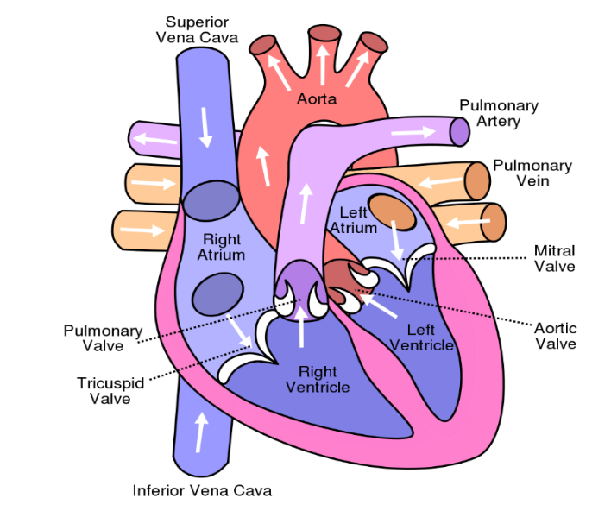

**Figure 1: Human Heart Image**

**Figure 2: Blockage in Coronary Artery**

**Figure 3: Classification of target value (y) w.r.t feature (x)**

**Figure 4: Basic Random Forest Model**

|  |  |  |  |  |
| --- | --- | --- | --- | --- |
|  | **Logistic Regression** | **Decision Tree** | **Gradient Boosting** | **Random Forest** |
| **Accuracy** | 0.689 | 0.6774 | 0.7097 | 0.7419 |
| **Precision** | 0.2727 | 0.7059 | 0.6818 | 0.7143 |
| **Recall** | 0.6186 | 0.7059 | 0.8824 | 0.8824 |
| **F1_micro** | 0.3806 | 0.7059 | 0.7737 | 0.7913 |
| **F1_macro** | 0.6471 | 0.7036 | 0.6969 | 0.7334 |

**Table 1 Results of Original Work of Framingham Dataset**

|  |  |  |  |  |  |  |
| --- | --- | --- | --- | --- | --- | --- |
|  | **Logistic Regression** | **Decision Tree** | **Gradient Boosting** | **Random Forest** | **K Nearest Neighbor** | **Support Vector Machine** |
| **Accuracy** | 0.853774 | 0.756132 | 0.850472 | 0.850708 | 0.835613 | 0.847170 |
| **Precision** | 0.730684 | 0.237028 | 0.543959 | 0.563462 | 0.364162 | 0.246667 |
| **Recall** | 0.063675 | 0.267139 | 0.085380 | 0.058963 | 0.113324 | 0.007752 |
| **F1_micro** | 0.853774 | 0.758019 | 0.849764 | 0.845755 | 0.835613 | 0.847170 |
| **F1_macro** | 0.518527 | 0.551712 | 0.532291 | 0.511493 | 0.540262 | 0.466086 |

**Table 2 Results of Original Work of Framingham Dataset**

|  |  |  |  |  |
| --- | --- | --- | --- | --- |
|  | **Logistic Regression** | **Decision Tree** | **Gradient Boosting** | **Random Forest** |
| **Accuracy** | 0.8065 | 0.7722 | 0.8465 | 0.841 |
| **Precision** | 0.7619 | 0.1923 | 0.5 | 0.2 |
| **Recall** | 0.9412 | 0.1546 | 0.0309 | 0.0103 |
| **F1_micro** | 0.8451 | 0.1681 | 0.031 | 0.0203 |
| **F1_macro** | 0.7983 | 0.7521 | 0.7203 | 0.1659 |

**Table 3 Results of Original Work of UCI Dataset**

|  |  |  |  |  |  |  |
| --- | --- | --- | --- | --- | --- | --- |
|  | **Logistic Regression** | **Decision Tree** | **Gradient Boosting** | **Random Forest** | **K Nearest Neighbor** | **Support Vector Machine** |
| **Accuracy** | 0.844878 | 0.997073 | 0.963902 | 0.997073 | 0.840976 | 0.895610 |
| **Precision** | 0.820902 | 1.000000 | 0.966067 | 0.994495 | 0.861634 | 0.879405 |
| **Recall** | 0.893621 | 0.986667 | 0.963899 | 1.000000 | 0.825085 | 0.924061 |
| **F1_micro** | 0.844878 | 0.996098 | 0.963902 | 0.994146 | 0.840976 | 0.895610 |
| **F1_macro** | 0.843966 | 1.000000 | 0.963873 | 0.997066 | 0.840850 | 0.895280 |

**Table 4 Results of Proposed Work of UCI Dataset**

**1. Logistic Regression**

**Figure 5: Confusion Matrix of Logistic Regression of Framingham Dataset**

**2. Decision Tree**

**Figure: 6 Confusion Matrix of Decision Tree of Framingham Dataset**

**3. Gradient Boosting**

**Figure 7: Confusion Matrix of Gradient Boosting of Framingham Dataset**

**4. Random Forest**

**Figure 8: Confusion Matrix of Random Forest of Framingham Dataset**

**5. K-Nearest Neighbor**

**Figure 9: Confusion**

**Matrix of K-Nearest Neighbor of Framingham Dataset**

**6. Support Vector Machine**

**Figure 10: Confusion**

**Matrix of Support**

**Vector Machine of Framingham Dataset**

**1. Logistic Regression**

**Figure 11: Confusion Matrix of Logistic Regression of UCI Dataset**

**2. Decision Tree**

**Figure 12: Confusion Matrix of Decision Tree of UCI Dataset**

**3. Gradient Boosting**

**Figure 13: Confusion Matrix of Gradient Boosting of UCI Dataset**

**4. Random Forest**

**Figure 14: Confusion Matrix of Random Forest of UCI Dataset**

**5. K-Nearest Neighbor**

**Figure 15: Confusion**

**Matrix of K-Nearest Neighbor of UCI Dataset**

**6. Support Vector Machine**

**Figure 16: Confusion Matrix of Support Vector Machine of UCI Dataset**

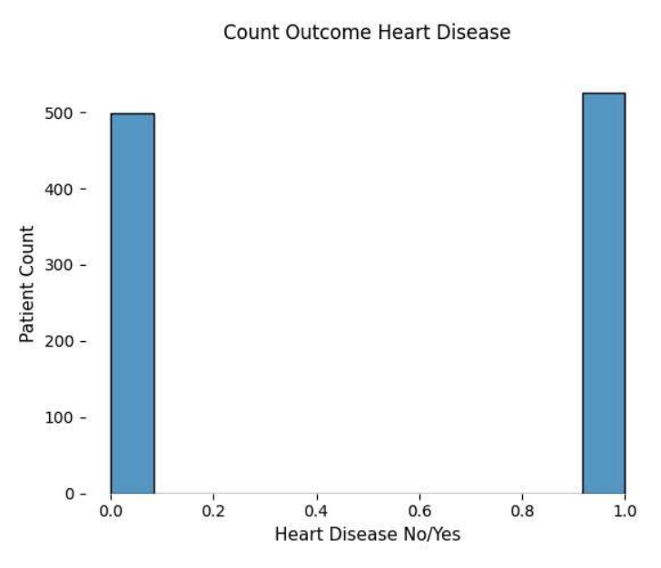

**Figure 17: Possibility of heart attack as per test-set**

**Figure 18: Possibility of heart attack with age distribution**

**Figure 19: Graphical representation for cholesterol level w.r.t. possibility of heart attack**

**Figure 20: Chest Pain Type**